DRAFT FACEBOOK POST COPY

Draft Facebook Post 1:
Creative used:  Campaign Video – Square  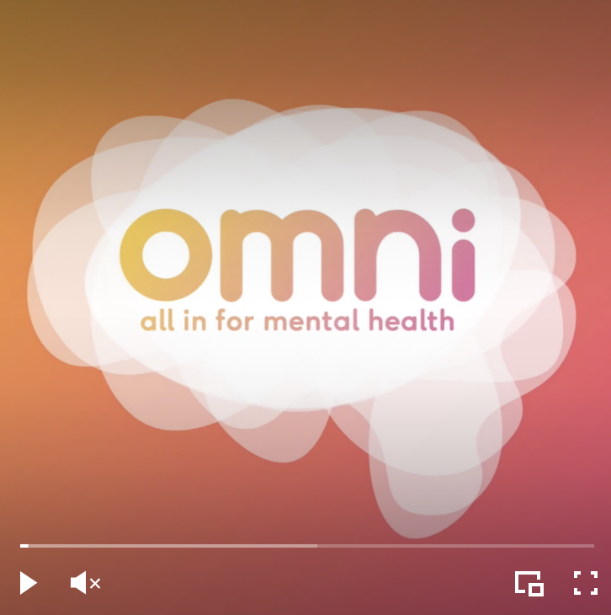 | Copy:  Remote learning, isolation, rising living costs, burnout...  What's impacting your mental health?  Please share your experiences so that we can change things at Queen's for the better.  Continue the movement. Take the survey.  omni.qubsu.org  #OMNIqubsu #qubsu #qub #LoveQUB #mentalhealth #queensuniversitybelfast
Draft Facebook Post 2:
Creative used:  Social Square  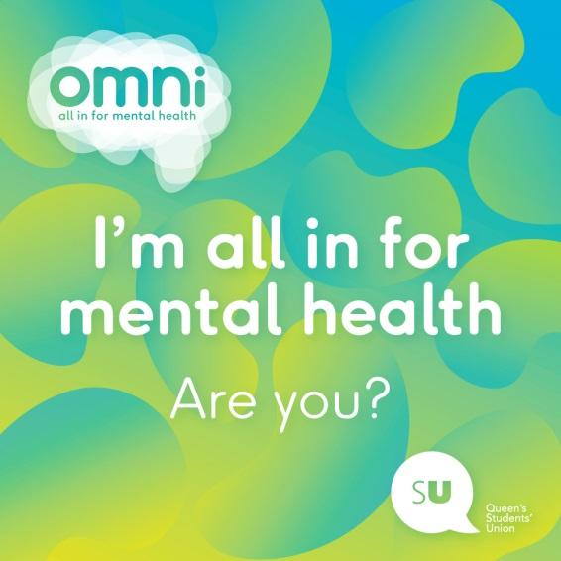 | Copy:  The OMNI movement sparked a conversation that echoed across campus and beyond. So much progress has been made but there’s so much more still to do.  Tell us what's impacting your mental health so we can continue to change things for the better @qubelfast.  Continue the movement. Take the survey.  omni.qubsu.org  #OMNIqubsu #qubsu #qub #LoveQUB #mentalhealth #queensuniversitybelfast

DRAFT TWEET COPY

Draft Tweet 1:
Creative used:  Campaign Video – Square | Copy:  Remote learning, isolation, rising living costs, burnout... What's impacting your mental health?  Share your experiences so that we can change things at Queen's for the better.  Continue the movement. Take the survey.  omni.qubsu.org  #OMNIqubsu #qubsu #qub #LoveQUB
Draft Tweet 2:
Creative used:  Social Square  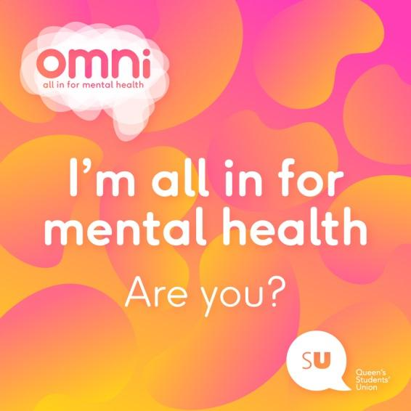 | Copy:  Tell us what's impacting your mental health so we can continue to change things for the better @qubelfast.  Continue the movement. Take the survey.  omni.qubsu.org  #OMNIqubsu #qubsu #qub #LoveQUB #mentalhealth #queensuniversitybelfast

